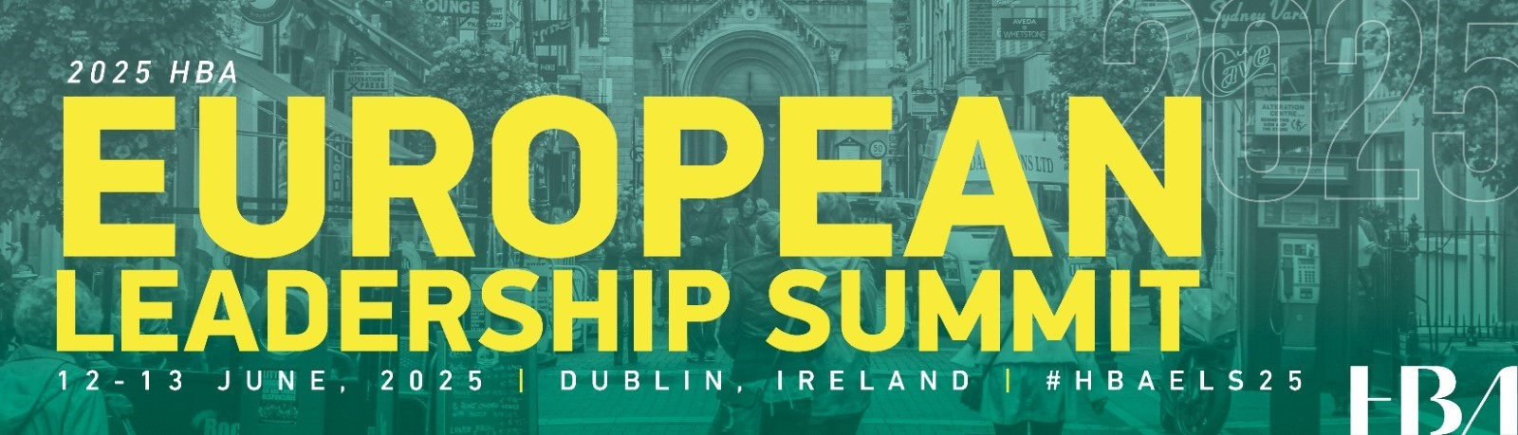

**Subject:** Key Takeaways from the European Leadership Summit

Dear [Manager's Name],

I’m writing to share highlights and actionable insights from my experience at the European Leadership Summit in Dublin. The event was incredibly valuable, offering a range of thought-provoking perspectives on leadership, innovation, and career advancement within the healthcare landscape.

The overarching theme, *“Creating Leaders for Life,”* resonated deeply and underscored the importance of continuous growth. The keynotes offered transformative perspectives. For example, *“The Indispensable Value of Breakthrough Leadership”* challenged me to lead not from limitations, but from the possibilities ahead. *“Communicating the Value of Healthcare Innovation in a Hesitant World”* reframed the issue of misinformation, reminding us that many leaders are more fearful than skeptical—and that powerful storytelling can build trust more effectively than counterarguments. *“How an Innovation Mindset Accelerates Your Career Trajectory”* provided practical strategies to streamline low-value work—too many meetings, emails, and busy work—in order to make space for creativity, deep thinking, and impact.

I was especially inspired by the keynote from the Ireland General Manager at Bristol Myers Squibb, *“Focusing on What’s Possible: The Journey Beyond the Status Quo.”* She encouraged us to craft our careers by leaning into our strengths and passions, even if it means deviating from traditional paths and venturing into unfamiliar territory as continuous learners

In the breakout sessions, I focused on [insert 1–2 relevant sessions], which provided practical frameworks I’m eager to bring back to our team. These sessions offered strategies I believe will directly support both individual growth and our broader organizational goals.

The corporate partner insight panels—such as *“Understanding the Patient Better to Provide Better Care”* and *“Elevating Standards of Care Through Innovation: Gaps and Gains”*—emphasized how innovation must remain rooted in patient-centricity. Even for those not directly involved in patient care, these conversations reinforced our collective responsibility to drive better outcomes and experiences across the healthcare ecosystem.

Outside the formal agenda, events like the sponsor marketplace and Dine Around Dublin [if applicable] provided valuable opportunities to connect with peers and industry leaders. These conversations expanded my perspective and revealed potential areas for future collaboration.

I’m excited to apply what I learned to support our team’s continued success. Specifically, I plan to:

* [Insert specific action #1]
* [Insert specific action #2, if applicable]
* [Insert specific action #3, if applicable]

Thank you for the opportunity to attend this impactful summit. I’m confident that the insights and strategies I’ve gained will help me lead more effectively and contribute more meaningfully to our goals.

Sincerely,  
[Your Name]