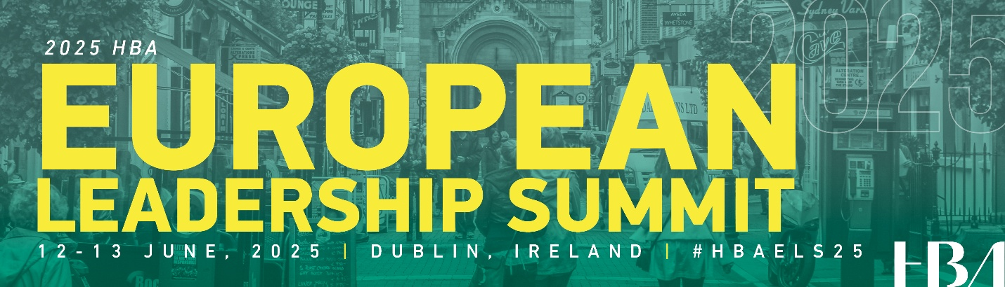

Dear [Supervisor’s Name],

I’m writing to request your support to attend the 2025 HBA European Leadership Summit, taking place June 12–13 at the Dublin Royal Convention Centre in Dublin, Ireland. This premier event brings together professionals from across Europe’s healthcare and life sciences ecosystem to foster leadership excellence, cross-border collaboration, and innovation that advances healthcare outcomes.

With the goal of “Empowering the Healthcare Workforce, Elevating Leadership, Advancing Healthcare Across Europe,” the Summit is designed to deliver actionable insights, professional development, and strategic connections that directly benefit both individual growth and organizational success.

What I Will Gain from Attending
Participation in the Summit will provide me with:

Inspiration from bold, visionary keynote speakers who are driving meaningful change across the healthcare sector.

Practical skills and leadership strategies through hands-on breakout sessions and leadership strategy workshops—covering topics such as breakthrough leadership, career pivots, intergenerational collaboration, sponsorship strategies, and stress management for high-stakes roles.

Insights into cutting-edge trends, including the economic impact of balanced leadership, the power of data in transforming healthcare across Europe, and the role of emerging technologies in elevating standards of care.

Direct exposure to best practices shared by executives during Corporate Partner Insight Panels—offering real-world leadership lessons and health equity strategies.

Facilitated small-group learning experiences via Connection Circles, designed for candid dialogue and practical peer exchange across roles, functions, and geographies.

Organizational Benefits
By attending, I will bring back:

Actionable ideas that can be immediately applied to my current role.

A broadened professional network of peers and thought leaders across the healthcare industry.

Insights on leadership practices that support innovation, talent development, and health leadership—all of which align with our organization's goals.

New tools and frameworks to support team performance, strategic decision-making, and long-term leadership development.

Anticipated Costs for Attendance
Registration Fee: €348 Member and Employee of a Corporate Partner, €578 Non-Member
Accommodation: €285 or €288 (depending on hotel)
Travel: [fill in expected expenses]
Meals: Lunch is included in registration. [Add anticipated breakfast and dinner expenses.]
Total: [Calculate Total]

The Healthcare Businesswomen’s Association is a globally respected nonprofit organization committed to developing leaders in healthcare. The European Leadership Summit is one of its most impactful events—offering a unique opportunity to connect with leaders and innovators from across Europe and beyond.

I would appreciate your consideration and support of this professional development opportunity. I am confident the experience will significantly benefit both my personal growth and our team’s strategic impact.

Thank you for your time and support. I’m happy to discuss how this aligns with our department’s priorities or provide additional information.

Warm regards,
[Your Name]
[Your Title/Department]

