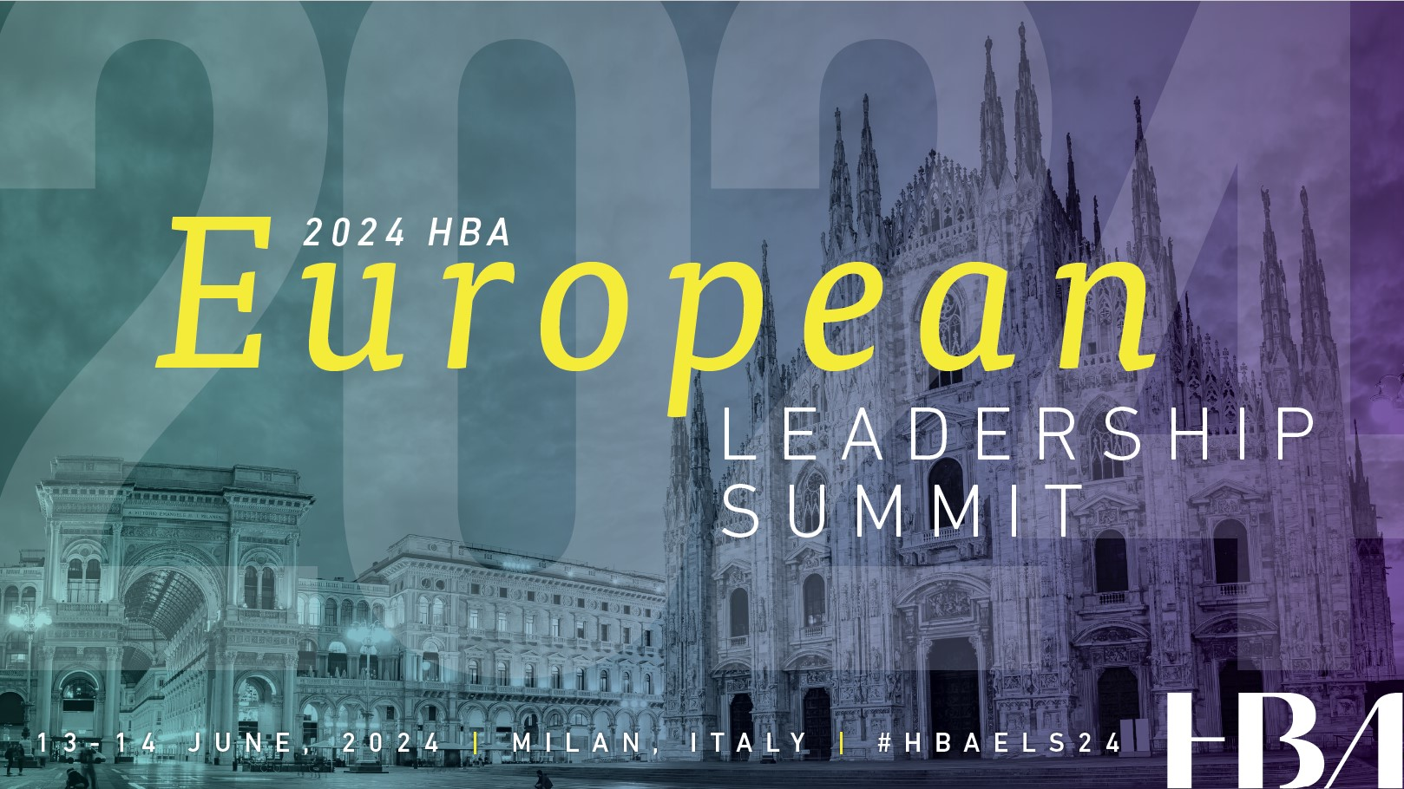

<Date>

Dear <Supervisor’s name>,

I am requesting your approval and support to attend the 2024 HBA European Leadership Summit.

When members of the Healthcare Businesswomen’s Association come together, it’s with a shared purpose: to be A United Force for Change; accelerating the impact and influence of women in the business of healthcare.

The 2024 in-person conference is designed to provide content and opportunities for me to expand my skills and my professional network, both of which directly benefit <our organization> and improve my individual performance.

Previous events have attracted more than 300 healthcare and life sciences industry professionals. By attending, I will be able to:
- explore the theme ‘Expanding Horizons’ through keynote and plenary sessions, workshops and panel discussions.
- build new and strengthen lasting connections through networking opportunities
- learn from thought leaders to broaden my perspective
- expand my business skills and acumen
- support the HBA’s core purpose of furthering the advancement and impact of women in the business of healthcare

I have identified a few educational sessions which will allow me to <insert benefits of attending topic specific sessions here (suggestions provided below)>. These sessions and presentations are led by industry experts and professionals known and recognized for their specific expertise.

This investment for my professional development is estimated as <$xxxx> for conference registration. The event agenda runs across two days from 13-14 June 2024.

Please confirm your approval of my request by <date>. Registration for the program is now open and seating is limited.

Thank you for your consideration,

Sincerely,

Suggestions for articulating the professional benefits associated with conference attendance:
- improve my leadership effectiveness
  - by learning about the power of diverse thinking and alternative perspectives in leadership
  - by exploring leadership in a new era and leading the next generation to support other women achieving success
- expand my industry knowledge
  - by understanding the impact of technology, including ai advances, on healthcare
  - by improving my ability to leverage industry dynamics to accelerate our business results
  - by interacting with individuals from across the industry ecosystem
- improve my value and contribution to the organization
  - by improving my professional presence and the effectiveness of my communications
  - by identifying ways to better leverage mentors and sponsors to accelerate my career
  - by focusing on taking the lead in women’s health

